RESUME
Dr.VEENA.N  No. 21, Shubha Krutu  Girl’s School Road,  Chickballapur-562101.  Phone: +91-9035863789  Email: veena.cbpur@gmail.com | 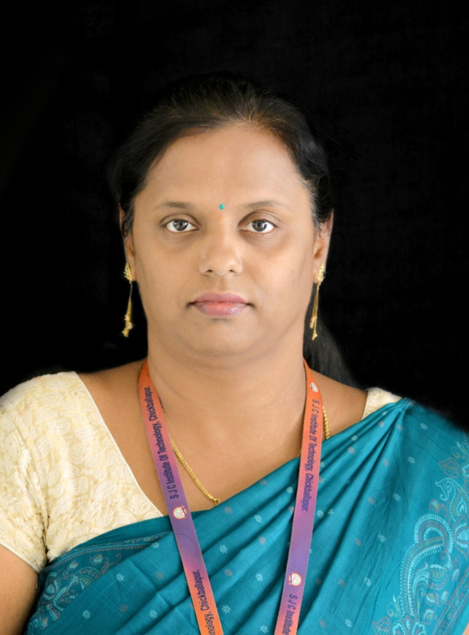

Languages Known | Kannada, English, Hindi
Education | Ph.D. [Applied Mathematics]  VTU, Belagavi  2008  M.Phil  Periyar university, Salem, Tamil nadu
Education | 2003  M.Sc. [Mathematics]  Central College, Bangalore University, Bangalore
Education | 2001  B.Sc. [Physics, Mathematics, Computer Science]  Sri Kongadiyappa Degree College, Dodballapur-561203
Professional experience | 2010 (July) – To till date  Assistant Professor  Department of Mathematics  S.J.C.I.T, Chickballapur-562101  2007 (July) – 2010 (July)  Lecturer  Department of Mathematics  M.S Engineering College, Bangalore  2006 – 2007  Lecturer  Department of Mathematics  NCET, Bangalore  2004-2006  Lecturer  Sri Kongadiyappa degree College, Dodballapur.
Subjects  Taught | - Calculus and Linear Algebra  - Advanced calculus and Numerical Methods  - Transform calculus,Fourier Series and Numerical Techniques  - Complex Analysis, Probability and Statistics  - Engg.maths- I  - Engg.maths- II  - Engg.maths -III  - Engg.maths -IV  - Mathematical methods  - Applied Mathematics  - Advanced Mathematics  - Optimization  - DMS
Papers published  Paper presented | - Published a paper titled by  - “Ohmic Heating Effect of Viscoelastic Dielectric Liquid over a Slanted Stretching Sheet”, International Journal of INTELLIGENT SYSTEMS AND APPLICATIONS IN ENGINEERING, ISSN:2147-6799, IJISAE, 2024, 12(22s), 1991–2003.  - “Dielectric Liquid Flow Over a Horizontal Stretching Sheet”, Journal of Thermal Analysis and Calorimetry, ISSN: Vol 148, Pages 11893-11902. ISSN: 1588-2926  DOI: https://doi.org/10.1007/s10973-023-12480-y  - “A study on heat and flow of viscoelastic dielectric liquid over an inclined stretching sheet”, Journal of Mines, Materials & Fuels, ISSN: Vol.71, Issue 11 November 2023, 2278–2288. ISSN:0022-2755. DOI: https://informaticsjournals.com/index.php/jmmf/issue/view/2589  “Flow of dielectric liquid over a gravity aligned stretching sheet”, RVJournal of Science Technology Engineering Arts and Management,3,1, 2022, 46-57, http://rvjsteam.rvce.edu.in/pdf/03/issue-1/6.Flow-of-Dielectric-Liquid-Over-a-Gravity-Aligned-Stretching-Sheet.pdf  - Presented a paper by the title “A study on heat and flow of viscoelastic dielectric liquid over an inclined stretching sheet” in international conference on 24th & 25th at Ramaiah Institute of Technology.  - Presented a paper by the title “Flow and heat transfer in viscoelastic dielectric liquid over a horizontal stretching sheet” in 3rd international conference held on on 10th & 11th at Reva university.  - Presented paper by the title “Effect of temperature dependent heat source on flow and Heat transfer in Maxwell’s dielectric liquids over horizontal stretching sheet” on 13th and 14th December 2019 at GSSSITW, Mysore and got best paper presentation.
Additional Qualification | Hindi Vidwan from Mysore Hindi Prachara Parishad .
Certification of Appreciation | - On 5th September 2022 received Certification of Excellence at SJC Institute of Technology for Teaching, Research and other Institutional/Departmental activities.  - For getting 100% result received Certification of Appreciation.
Subjects  Taught | - Calculus and Linear Algebra  - Advanced calculus and Numerical Methods  - Transform calculus,Fourier Series and Numerical Techniques  - Complex Analysis, Probability and Statistics  - Engg.maths- I  - Engg.maths- II  - Engg.maths -III  - Engg.maths -IV  - Mathematical methods  - Applied Mathematics  - Advanced Mathematics  - Discrete MathematicsStructure  - Mathematics-I for CSE stream  - Mathematics-II for MEC stream  - Mathematics-III for CSE stream  - Discrete mathematics
Hobbies |  | - Listening to music , Craft work
Personal
Born on May 20, 1980.
Religion : Hindu
Nationality : Indian
Marital Status : Married
Participation in Conferences, Symposia, Seminars, FDPs and Workshops
1 Attended one week FDP on “A Multidisciplinary approach of Mathematics in Engineering” from 8th to 12th September 2025 at RIT, Bengaluru
Attended one week FDP on “GRAPH THEORY &OPTIMIZATION TECHNIQUES” from 23-28 September 2024 at RIT, Bengaluru.
2 Attended “VTU e-consortium training for faculties 16th October 2024 BMSIT&M, Bengaluru Participated
2 Attended Six days FDP on “Graph theory and Optimization Technique” at RIT 23rd September to 29th September 20224 RIT, Bangalore Participated
3 Delivered an Expert talk on Applications of Mathematics for ECE and EEE students. 11th December 2023 BMSIT&M Presented
4 Attended online teachers training program on “Robotics and Artificial Intelligence” organized by AICTE-VTU joint training program 24th to 28th April 2023 National Participation
5 One day National level workshop on “Python in Mathematics” 3rd May 2023 National Participation
6 National level online workshop on “Origin Software” 28th May 2023 National Participation
7 Virtual Workshop on “Introduction to Mathematical Ecology” organized by SRMIST. 4th February 2022. International Participation
8 FDP on “Math modeling and computational Modeling” organized by CMRIT. 24th to 28th January 2022. Participation
9 FDP on “Inculating Universal Human Values in technical Education” organized by AICTE. 17th May to 21st May 2021. Participation
10 Online FDP on “Linear algebra and its Applications” organized by the department of mathematics BMSIT 10th May to 15th May 2021. National Participation
11 Virtual Workshop on “Introduction to Mathematical Ecology” organized by SRMIST. 4th February 2022. International Participation
12 FDP on “Math modeling and computational Modeling” organized by CMRIT. 24th to 28th January 2022. Participation
13 FDP on “Inculating Universal Human Values in technical Education” organized by AICTE. 17th May to 21st May 2021. Participation
14 Online FDP on “Linear algebra and its Applications” organized by the department of mathematics BMSIT 10th May to 15th May 2021. National Participation
15 Webinar on Concept and applications of probability and statistical methods for students and faculties 10th May 2021. Participation
16 Online workshop on IEEE reference management tool for Research articles and thesis writing. 20th May 2020. Participation
17 4th IEEE International conference on Electrical, Electronics, Communication, Computer Technologies. 13th -14th December 2019 at GSSSITW, Mysore. International Presented Paper
18 “Inculcating Universal Human Values in Technical Education” organized by AICTE, 5 days 17th-21st May 2021 National level.

DECLARATION
I hereby confirm that all the information furnished above is true and correct.

(Veena.N)

